DEEP-LEARNING BASED DEEPFAKE VIDEO DETECTION SYSTEM USING ENSEMBLE LEARNING

126003238 Selvakarthik S
126003241 Shanthosh Kumar R
126015077 Prasad E

ABSTRACT:

The rapid advancement of generative models such as GANs and diffusion-based architectures has significantly increased the realism of synthetic videos, making robust deepfake detection an important research challenge. Existing approaches, including CNN-based detectors, hybrid CNN architectures, spatiotemporal networks, and optimization-driven feature extraction methods such as ACO-PSO and Jaya-based CNN frameworks, have demonstrated promising performance on benchmark datasets such as FaceForensics++, Celeb-DF, VoxCeleb, and the Deepfake Detection Challenge (DFDC). However, many of these methods rely on uniform frame processing or static feature aggregation, limiting their ability to capture temporally sparse inconsistencies and cross-modal anomalies introduced during synthetic video generation. To address these limitations, we propose a hybrid deep learning framework that introduces a novel landmark-guided golden frame selection strategy combined with cross-modal attention-based fusion. The proposed system focuses analysis on geometrically unstable regions likely to contain generative artifacts and leverages complementary expert models operating across spatial, frequency, and motion domains. By enabling dynamic interaction between feature representations rather than conventional score-level averaging, the framework aims to improve robustness and interpretability under challenging conditions such as motion, compression, and lighting variations.

References:

[1] Lipianina-Honcharenko, K., Melnyk, N., Ivasechko, A., Telka, M., & Illiashenko, O. (2025). Neural Network Ensemble Method for Deepfake Classification Using Golden Frame Selection. Big Data and Cognitive Computing, 9(4), 109.

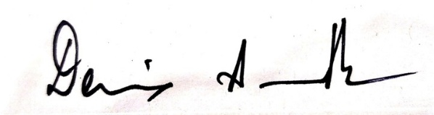
Dr. Dennis Ananth A

